DMA PTA
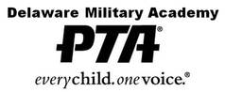
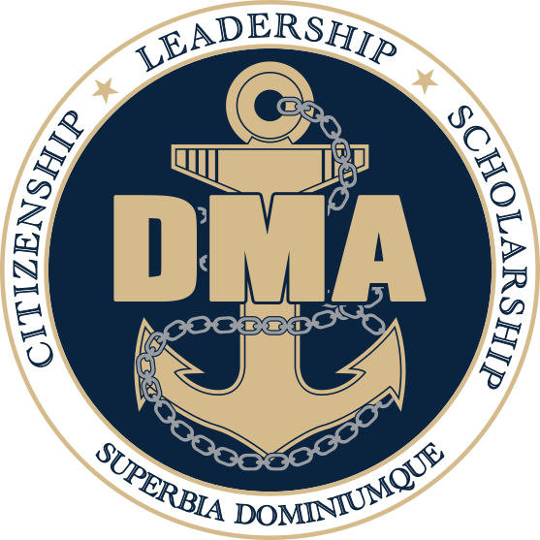
Meeting Agenda
February 15, 2024

- Call Meeting to Order and Welcome: Jen Avery
- Commandant’s Report: Dr. Sharon Kurfuerst
- Secretary: No December Meeting Megan O’Donnell
- Treasurer’s Report: Renee Hafer

- Vice President(s) Report: Lee Sobicinski (co)
Sue Cressman (co)
- VP Communications Report: Jayce Leon
- Committee Reports:
- Activities Committee Erin Marino
- Friday Lunch Angie Pankiw
- Hospitality Hilary Raptis
- Membership Tami Soltow
- Military Support Anne Kuennen
- Staff Appreciation Stacey Chakwin

- Old Business
- New Business
- Motion to Adjourn

Next Meeting: Thursday, March 21, 2023 @ 6:30pm

**Important Dates**
PTA Meeting Dates:
March 21, 2024
April 18, 2024
May 16, 2024 *Elections*

Other PTA Involved Activities
Service Academy Night 9/11 Ceremony Back to School Night
Choice Open House Veteran’s Breakfast Food Drive
Dining In Academic Awards Night NJROTC Awards Night
Jr. Ring Ceremony NHS Induction Senior Breakfast
End of Year Picnic New Cadet Orientation Picnic

PTA Fundraising
The PTA sells a pizza lunch every Friday – It is our primary fundraiser.
Please consider signing up for Friday lunch help. We rely on volunteers to help make it successful.
https://www.signupgenius.com/go/30E0B4EAFAD2DABFF2-46815856-20232024#/

*Upcoming Important Dates*
Feb 16th – Virtual Day
Feb 19th – No School
Feb 20th – MP3 Interims Distributed
Feb 26th – Spring Sports Begin
Feb 26th – DMA Board Meeting 6pm
Feb 29th – Evening Parent Conferences 5p-8p
Mar 6th – ASVAB for Juniors 7:30a-10:30a
Mar 9th – SAT Test Date
Mar 11th – No School
Mar 12th – Music Assoc Meeting 6:30p-8:30p
Mar 13th – Prom Ticket Sales (Seniors Only)
Mar 14th Prom Ticket Sales (Junior & Senior)
Mar 20th-21st – Spring Midterms
Mar 21st – PTA Meeting 6:30p
Mar 22nd – Virtual Day
Mar 25th – DMA School Board Meeting 6p
Mar 26th – SAT & PSAT 10
Mar 28th – MP# Report Cards Distributed
Mar 29th-Apr 5th – No School

